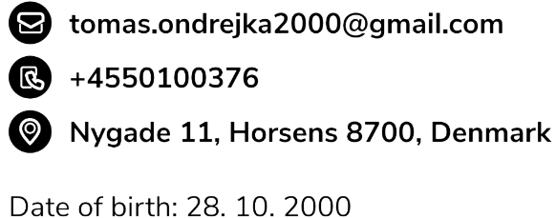

Dear Hiring Manager,

I am writing this letter to express my interest in the Full Stack Student Developer position at Clearhaus.com. As a Software Engineering student, I possess various development skills that make me a perfect candidate for the position.

I am currently taking a Bachelor degree at Via University College. While working on projects in school, I have developed a skill to adapt to every situation I am in and come up with creative solutions to problems that can occurr. Developing semester projects taught me how to cooperate in a group of software developers and how to together achieve the best result possible. My Git and Github knowledge expanded to a proficient level. Waterfall and Scrum methodologies were strictly followed during the projects for the highest learning outcome. Our lastest project is about creating the backend and frontend applications of e-commerce site for selling experience products.

I am proficient with a number of programming languages, including JavaScript, Java, C#. Currently, I am working as a Game Developer at TrainYourEyes.dk where I am creating exercises in JavaScript and TypeScript. My work is now used for helping people with various types of sight problems. Because TrainYourEyes.dk is not a software company, I have developed a skill to work independently, solve complex problems with the only help of google and communicate each requirement with the client.

Because of my solid knowledge of programming languages and my passion, I have a foundation for learning new technologies and frameworks that can benefit your company. I am an excellent team player with attention to detail and with the knowledge required for the position.

Please do not hesitate to reach out if you have any questions about my background, projects or my skills. I look forward to the opportunity to speak with you further.

Thank you for your time and consideration.

Sincerely,

Tomas Ondrejka